# Timeline Description automatically generatedDigital Marketing

# BI into Digital Marketing

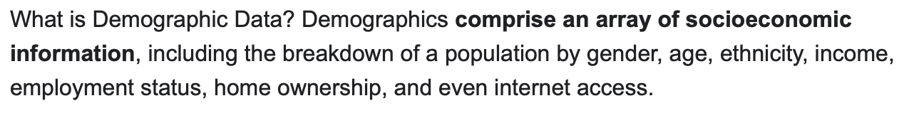

<https://nix-united.com/blog/how-to-leverage-business-intelligence-for-marketing/#:~:text=Business%20intelligence%20for%20digital%20marketing%20empowers%20businesses%20with%20customer%20insight,prioritize%20workflows%2C%20and%20enhance%20productivity>.

<https://www.searchlaboratory.com/us/2021/05/business-intelligence-bi-in-digital-marketing/>

<https://www.stitchdata.com/resources/business-intelligence-digital-marketing/>

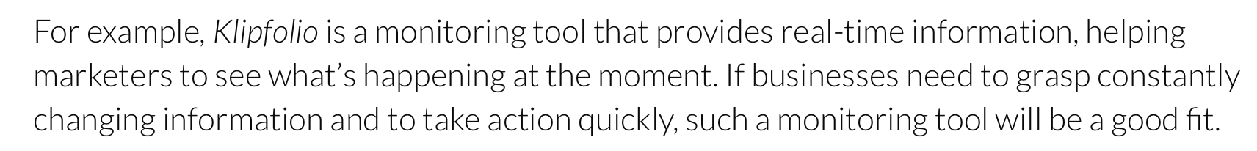

<https://60secondmarketer.com/2018/04/23/the-vital-role-of-business-intelligence-in-digital-marketing-today/>

<https://www.curvearro.com/blog/2020/01/10/role-of-business-intelligence-in-digital-marketing/>

Search Engine Optimization

###########################################################################

Web Analytics

Salutations

